# Cybersecurity Project

# 21/06/2024

# Monthly Project report

**For further information:**

Jarna Salonen 13229846

Shehreen Haider 13247624

Nick Woolcock

# Guide

## Monthly Project tracking meetings

Refer to Gant Chart and Trello

Meeting 15+5 minutes

* referring to MS Project Gant Chart and Trello board
* Monitor progress and track:
  + Procurement – N/A
  + Project progress to timelines – We are on track according to the Gantt Chart. All milestones are being met as scheduled.
  + Identify and document variations – No variation at this stage.
  + Monitor risks – update risk register - No new risks identified. The risk register remains up to date with no changes.
  + Quality (Testing) - The prototype is verified to be meeting the project's technical requirements. All tests indicate compliance with the specified criteria.
  + Budget progress relative to projections - The project budget is on track with the financial projections. No significant deviations observed.
  + Critical path analysis - Prototype development, production setup, documentation, and presentation are identified as critical paths. These areas are progressing as planned.
  + Sprint Retrospective – Team's efforts to help each other, improved collaboration
* Meeting minutes – Notes are being taken on the Trello board.
* Documentation – Monthly production report for submission detailing the progress, milestones achieved, and any issues encountered.
* Retrospective (5 Mins)

## Procurement progress and tracking

* Initiation and prototype development has been completed. Trello board has been set up for sprints and completed task. Gantt chart will be completed as required.

## Project progress to timeline:

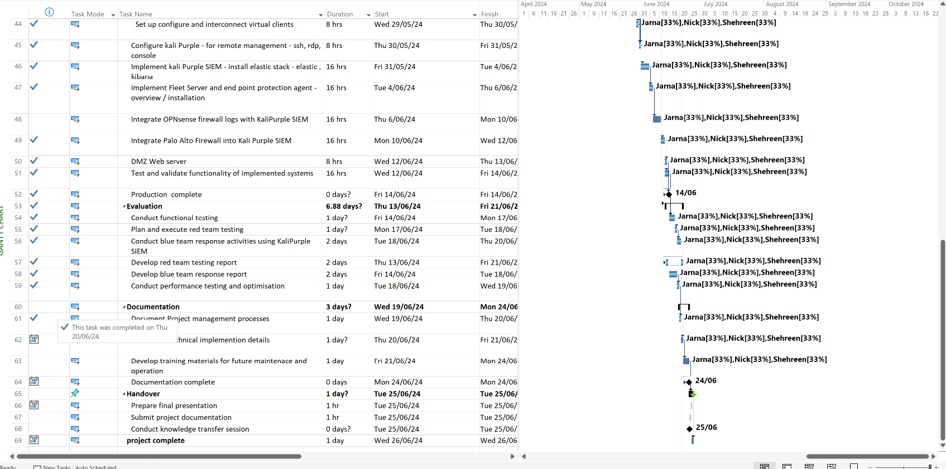

* Initiation completed.
* Prototype Development completed.
* Production development partially completed.

## Identify and document variations

* List of variations and impact of each (impact cost + time) - None

**Monitor risks – update risk register**

| Id | Description of Risk | Impact or consequence | Likelihood/ Seriousness | Grade | Change | Mitigation Actions  (Preventative or Contingency) | Individual/Group Responsible for Mitigation Action | Timeline for Mitigation Action |
| --- | --- | --- | --- | --- | --- | --- | --- | --- |
| **1** | **Project Completed to documenatation stage** | **Completed** |  | **0** | **N/A** |  | **Whole team** | **Completed** |

**Quality - Verify Prototype is meeting project technical requirements**

* **Criteria of project outputs**

GANTT Chart established with baseline and cost projections.

* **Testing procedures used so far to verify quality of outcomes**

Completed.

* **Paragraph summary**

Testing has been completed and we are satified we have met Mitre 8 Level 1 Maturity compliance.

**Budget progress relative to projections:**

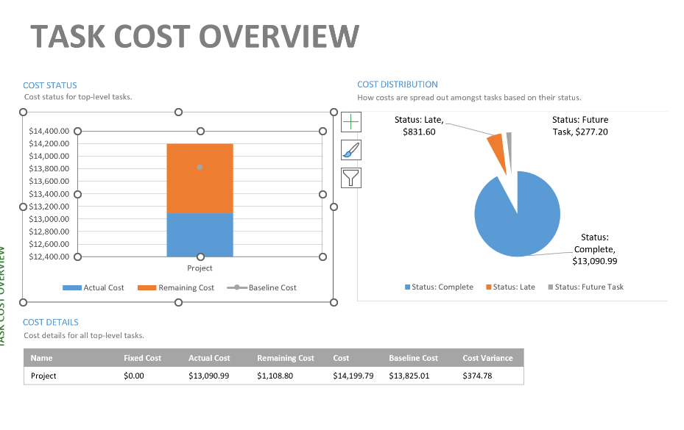

* Project currently running to budget and baseline projections.

**Critical path analysis**

**Sprint retrospective**

* **What went well** – Team members actively helped each other with tasks, as a result, we were able to complete the prototype successfully.
* **What needs Improvement** – Better understanding and knowledge on technical project tasks. There were some delays in configuring DMZ WEB server within the planned sprint timeframe. This was partly due to unexpected complexities in the setup process.
* **Actions:** All team members will share their understanding and approach on how to complete the production environment setup and conduct some testing of the environment.
* **Summary:**

Overall, we were able to completed tasks for production Network correctly. Some team members are working on creating a shared knowledge base where team members can document solutions and troubleshooting steps.

### Activities:

1. Update Project documentation (monthly report) to include items discussed in progress report
2. Revise Gantt chart
3. Update risk register
4. Monthly project tracking meeting minutes documented
5. Sprint retrospective

### References:

Critical path - <https://support.microsoft.com/en-us/office/show-the-critical-path-of-your-project-in-project-desktop-ad6e3b08-7748-4231-afc4-a2046207fd86>

MS Project cost totals - <https://support.microsoft.com/en-us/office/view-project-cost-totals-0d3a2451-fb1e-4ba0-826e-20ee3b3d60cc>

Baseline – MSProject - <https://support.microsoft.com/en-us/office/create-or-update-a-baseline-or-an-interim-plan-in-project-desktop-7e775482-ac84-4f4a-bbd0-592f9ac91953>

**MS project reports**

Project > project Information > Statistics

Report > costs > task cost overview

Report > In progress > Milestone report

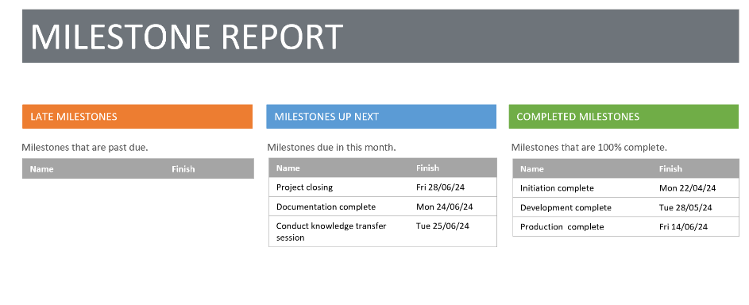

Report > resources > resource Overview

**Key to Risk Rating Symbols used:**

|  |  |  |  |
| --- | --- | --- | --- |
| Rating for Likelihood and Seriousness for each risk | | | |
| L | Rated as Low | E | Rated as Extreme (Used for Seriousness only) |
| M | Rated as Medium | NA | Not Assessed |
| H | Rated as High |  |  |

|  |  |  |  |  |  |
| --- | --- | --- | --- | --- | --- |
| Grade: Combined effect of Likelihood/Seriousness | | | | | |
|  | Seriousness | | | | |
| Likelihood |  | low | medium | high | EXTREME |
| low | N | D | C | A |
| medium | D | C | B | A |
| high | C | B | A | A |

|  |  |
| --- | --- |
| Recommended actions for grades of risk | |
| Grade | Risk mitigation actions |
| A | Mitigation actions to reduce the likelihood and seriousness to be identified and implemented as soon as the project commences. |
| B | Mitigation actions to reduce the likelihood and seriousness to be identified and appropriate actions implemented during project execution. |
| C | Mitigation actions to reduce the likelihood and seriousness to be identified and costed for possible action if funds permit. |
| D | To be noted - no action is needed unless grading increases over time. |
| N | To be noted - no action is needed unless grading increases over time. |

|  |  |  |  |
| --- | --- | --- | --- |
| Change to Grade since last assessment | | | |
| NEW | New risk | ↓ | Grading decreased |
| — | No change to Grade | ↑ | Grading increased |